**Final Practical Exam**

**Student Name:** Sahil Kaundal **UID:** 21BCS8197

**Branch:** BE CSE (Lateral Entry) **Section/Group:** 807/B

**Semester:** 4th **Date of Performance:** 20/05/2022

**Subject Name:** MPI Lab **Subject Code:** 22E-20CSP-253

1. **Aim/Overview of the practical:**

Write a program to find the 2’s complement of 16-bit number stored in memory locations 3000H and 3001H.

**2. Task to be done/ Which logistics used:**

Write a program to find the 2’s complement of 16-bit number stored in memory locations 3000H and 3001H.

**3. Apparatus / Simulator Used:**

1. Jubin Application

2. 8085 Simulator

3. JDK

**4. Algorithms/Flowcharts:**

* A program to find the 2’s complement of 16-bit number stored in memory locations 3000H and 3001H.

1. Load a 16-bit number from memory 3000 into a register pair (H-L)
2. Move content of register L to accumulator
3. Complement content of accumulator
4. Move content of accumulator to register L
5. Move content of register H to accumulator
6. Complement content of accumulator
7. Move content of accumulator to register H
8. Store content of register pair in memory 3002 (**1’s** complement)
9. Increment content of register pair by 1
10. Store content of register pair in memory 3004 (**2’s** complement)
11. Stop

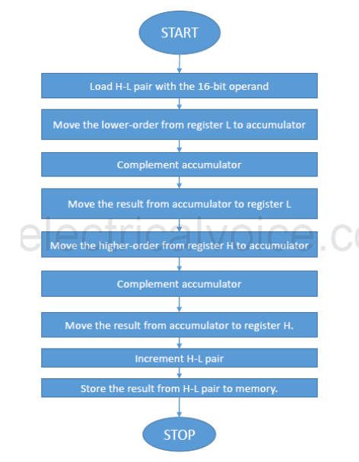

**5. Programs:**

* A program to find the 2’s complement of 16-bit number stored in memory locations 3000H and 3001H.

# BEGIN 0000H

LXI H,3000

MVI B,00

MOV A,M

CMA

ADI 01

STA 3002

JNC GO

INR B

GO: INX H

MOV A,M

CMA

STA 3003

HLT

# ORG 3000

# DB 12H,05H

**6. Result/Output/Writing Summary:**

* A program to find the 2’s complement of 16-bit number stored in memory locations 3000Hand 3001H.

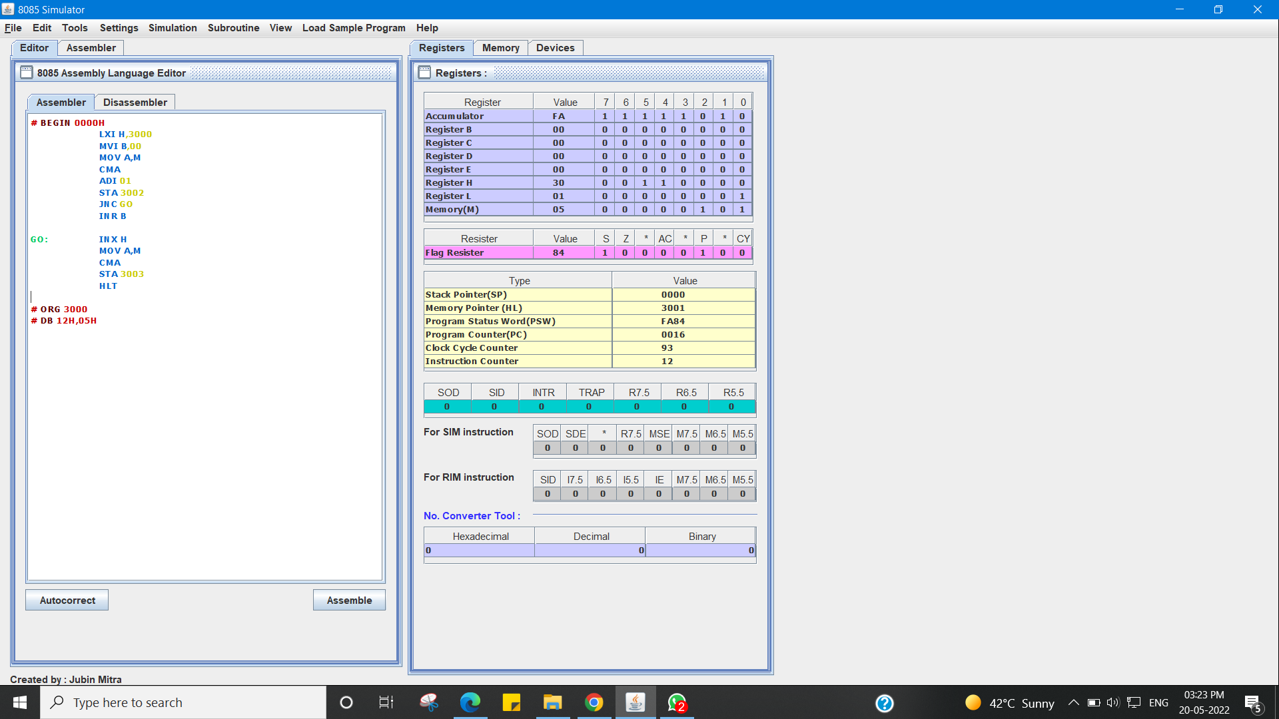

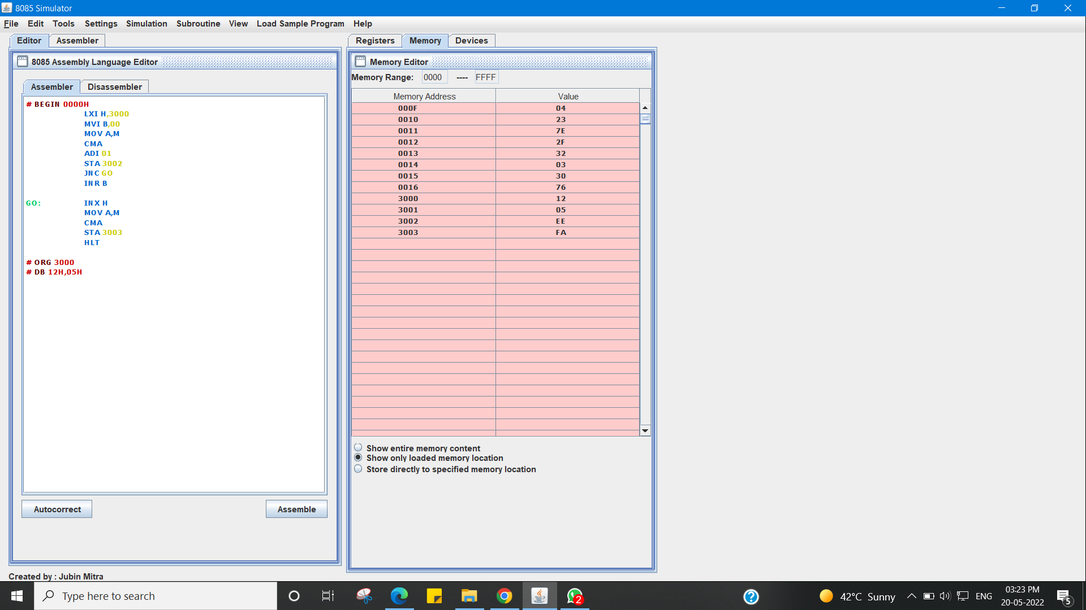

I Have Successfully Done This Practical.

**Evaluation Grid (To be created as per the SOP and Assessment guidelines by the faculty):**

|  |  |  |  |
| --- | --- | --- | --- |
| Sr. No. | Parameters | Marks Obtained | Maximum Marks |
| 1. |  |  |  |
| 2. |  |  |  |
| 3. |  |  |  |
|  |  |  |  |